Network Security (CCF2C01)
Case Study Report Submission

Practical Class: P05
Submitted by: 2100902B Isaac Tan

Date: 09/11/2022

“By submitting this work, I am declaring that I am the originator of this work and that all other original sources used in this work has been appropriately acknowledged.

I understand that plagiarism is the act of taking and using the whole or any part of another person’s work and presenting it as my own without proper acknowledgement.

I also understand that plagiarism is an academic offence, and that disciplinary action will be taken for plagiarism.”

Name and Signature of student:



School of Informatics & IT

AY 2022/2023 Oct Semester (Level 2)
Diploma In Cybersecurity & Digital Forensics
Network Security (NWS)
[Subject Code – CCF2C01]

ASSIGNMENT REPORT

FOR

NETWORK SECURITY

(INDIVIDUAL)

Suggested Assignment Report Format / Contents:

I have been tasked to design and implement a secure internetwork for a local company Tem Pora Pte Ltd (TP) with its main headquarter (HQ) located at Shentonway and a branch office (BRANCH) located at Jurong Business Park.
The company has a strict security requirement for the corporate network as listed below:
Part 1 – Implementation issues
Part 2 – VLSM IP addressing design issues
Part 3 – DHCP, NAT/PAT and Wireless LAN implementation issues
Part 4 – Security implementation issues which includes the following
4.1 – Router Hardening
4.2 – Switch Hardening
4.3 – Firewall implementation issues
4.3.1 – IOS ZPF without DMZ implementation at BRANCH router
4.3.2 – IOS ZPF with DMZ implementation at HQ FW router

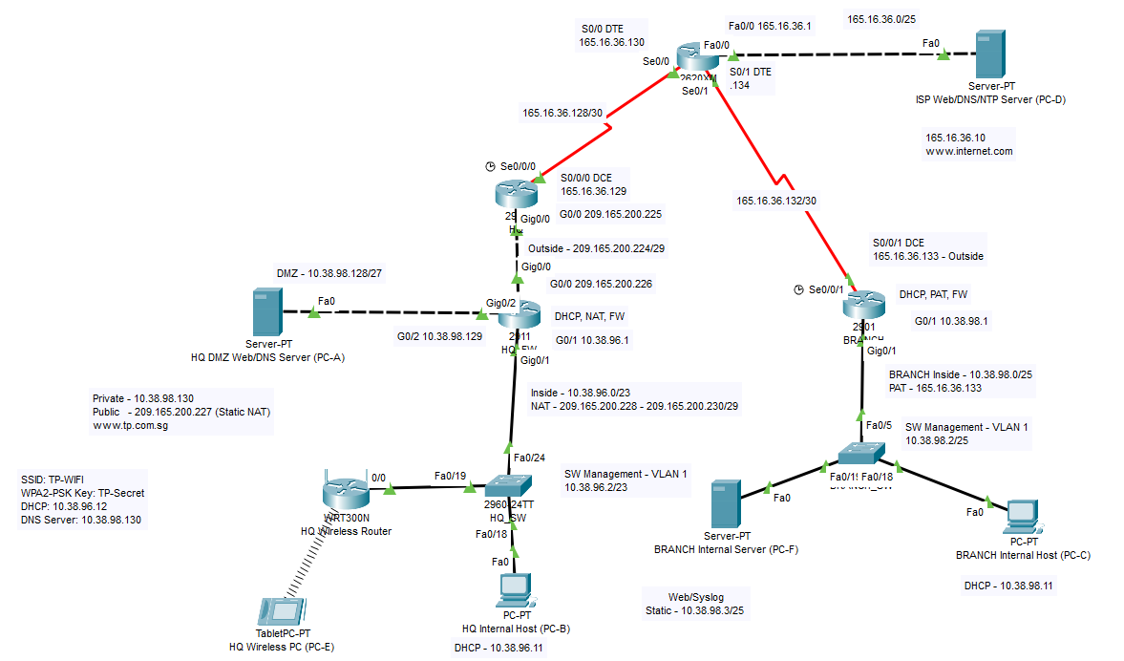

- Static/Default Routing Implementation
ISP Router
Commands:
int s0/0
bandwidth 1000000
exit

int s0/1
bandwidth 2048
exit

ip route 209.165.200.224 255.255.255.248 165.16.36.129

Verification:
show int s0/0
shows that interface s0/0 is connected to the 165.16.36.128/30 LAN and has 1000000 bandwidth (1Gbps WAN connection).
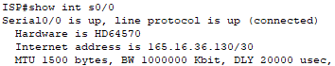

show int s0/1
Shows that interface s0/1 is connected to the 165.16.36.132 LAN and has 2048 bandwidth (2.048Mbps WAN connection).
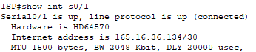
show ip route static
Created a recursive static route, has next-hop ip of HQ perimeter router to public network address of HQ.
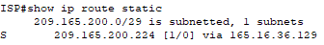
HQ Router
Commands:
int s0/0/0
bandwidth 1000000

ip route 0.0.0.0 0.0.0.0 165.16.36.130
ip route 192.168.99.0 255.255.255.192 209.165.200.226
ip route 192.168.96.0 255.255.254.0 209.165.200.226

Verification:
show int s0/0/0
Shows that interface s0/0/0 is also connected to 165.16.36.128/30 LAN and has 1000000 bandwidth WAN connection.
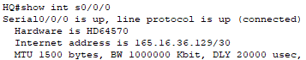
show ip route static
Created recursive static route, has next-hop ip of HQ Firewall router to HQ internal private network address and DMZ network address.
Default static route going outwards HQ network to next-hop ip of ISP router is also displayed.
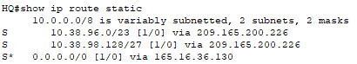
BRANCH Router
Commands:
int s0/0/1
bandwidth 2048

ip route 0.0.0.0 0.0.0.0 165.16.36.134

Verification:
show int s0/0/1
Interface s0/0/1 connected to 165.16.36.132/30 LAN and also has 2048 bandwidth WAN connection.
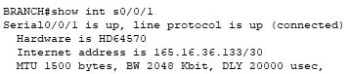
Default static route going outwards BRANCH network to next-hop ip of ISP Router is displayed.
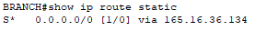

- VLSM IP Addressing Design
Propose solutions to satisfy the IP addressing requirements for the various LANs/VLANs (including relevant workings). Your VLSM design should be as efficient as possible, and list down any unused / spare IP address range reserved for future use. Fill up Table 1 accordingly. Include comments on any additional advantages and disadvantages of your proposed IP addressing solutions.

Private IP Address Range: 10.38.96.0 – 10.38.98.160
HQ Private Internal LAN: 450 Hosts
HQ DMZ LAN: 25 Hosts
Branch Office Private Internal LAN: 100 Hosts

subnet 1 – 450 hosts /23
start – 10.38.96.0
end – 10.38.97.255

subnet 2 – 100 hosts /25
start – 10.38.98.0
end – 10.38.98.127

subnet 3 – 25 hosts /27
start – 10.38.98.128
end – 10.38.98.159
Table 1: Interfaces used and IP addresses

LAN / WAN | Router /  Firewall | Interface | Network Address | IP address
HQ external public LAN  (outside) | HQ perimeter  router | G 0/0 | 209.165.200.224/29 | 209.165.200.225/29
 | HQ firewall  router | G 0/0 |  | 209.165.200.226/29
HQ DMZ LAN (Sacrificial LAN)  (DMZ) | HQ firewall  router | G 0/2 | 10.38.98.128/27 | 10.38.98.129/27
 | HQ DMZ Web/DNS server | Fa0 (NIC) |  | 10.38.98.130/27
HQ internal private LAN  (inside) | HQ firewall  router | G 0/1 | 10.38.96.0/23 | 10.38.96.1/23
 | HQ switch | Mgmt VLAN Interface VLAN1 |  | 10.38.96.2/23
HQ wireless  LAN | HQ wireless  router | HQ wireless LAN  connections | 192.168.0.0/24 | Obtain via DHCP service from HQ wireless router  (start from 192.168.1.100)
Branch internal private LAN  (inside) | Branch perimter  router | G 0/1 | 10.38.98.0/25 | 10.38.98.1/25
 | Branch  switch | Mgmt VLAN Interface VLAN1 |  | 10.38.98.2/25
 | Branch internal  Web.Syslog server | Fa0 (NIC) |  | 10.38.98.3/25
Public WAN between HQ  and ISP | HQ perimeter  router | S 0/0/0  (DCE) | 165.16.36.128/30 | 165.16.36.129/30
 | ISP  router | S 0/0/0  (DTE) |  | 165.16.36.130/30
Public WAN between Branch and ISP | Branch perimeter  router | S 0/0/1  (DCE) | 165.16.36.132/30 | 165.16.36.133/30
 | ISP  router | S 0/0/1  (DTE) |  | 165.16.36.134/30
ISP Router LAN | ISP  router | Fa 0/0 | 165.16.36.0/25 | 165.16.36.1/25

Part 2.
Task 3 Question: What is the disadvantage of this implementation, and how would you suggest to overcome it?

The disadvantage of VLSM Addressing is that it is very easy to make mistakes in assigning the addresses due to the nature of human error, since the addresses are within the same subnets and this could get much more complicated and confusing, hence the increasing difficulty in monitoring and keeping track of the network with all these subnets.

Since human errors occur naturally, there is only so much we can do to prevent them, hence, it is important to be extremely careful when assigning the addresses. In my opinion, I would suggest to plan out the addresses in a very organised manner, such that it would not be so confusing and messy from the addressing design of the many subnets and addresses. For example, I would make a table and list all the devices along with the assigned addresses so that I can be more careful and keep track and constantly refer to the table to double-check my work.

Task 4 Question: Why do servers need static IP addresses?

The servers need to be accessed by external devices or for devices that must be accessible by authroised personnel when offsite.

Task 5 Question: List down any additional advantages/disadvantage of your proposed IP addressing solutions, if any.

Another disadvantage of VLSM Addressing is that there is a very high possibility of assinging overlapping subnets, since there are so many other similar addresses that are within the same subnet.

An advantage of using the VLSM method is that there is minimum wastage of IP Addresses, unlike for Fixed Length Subnet Mask (FLSM) method, where there are wastages of IP Addresses.
Furthermore, VLSM has a more efficient use of allocated IP Address space

Task 3.
HQ Router Configurations
Interface S0/0/0
Assigned the bandwidth 1000000 (1Gbps WAN Connection) to the HQ Router S0/0/0 Interface.
Verification
show run | section interface Serial0/0/0
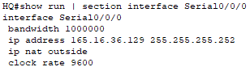
HQ_FW Router Configurations
Interface G0/1 – HQ Internal LAN
Assigned the first IP Address from the subnet 10.38.96.0 as 10.38.96.1 and subnet mask 255.255.254.0 to the HQ_FW Router G0/1 Interface.
Interface G0/2 – DMZ LAN
Assigned the first IP Address from the subnet 10.38.98.128 as 10.38.98.129 and subnet mask 255.255.255.224 to the HQ_FW Router G0/2 Interface.

Verification
show run
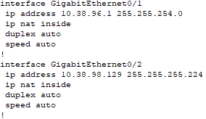
BRANCH Router Configurations
Interface S0/0/1
Assigned the bandwidth 2048 (2.048 Mbps WAN Connection) to the BRANCH Router S0/0/1 Interface.
Verification
show run | section interface Serial0/0/1
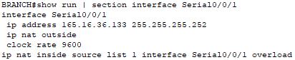
Interface G0/1 – BRANCH Internal LAN
Assigned the first IP Address of the LAN subnet as 10.38.98.1 and subnet mask 255.255.255.128 to the BRANCH Router G0/1 Interface.

Verification
show run | section interface GigabitEthernet0/1
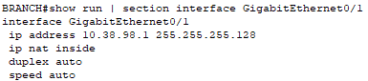
HQ_SW Switch Configurations
Assigned the second available IP Address of the HQ Internal Private LAN subnet of 10.38.96.2 with subnet mask 255.255.254.0 to the vlan1 interface.
Verification
show vlan brief
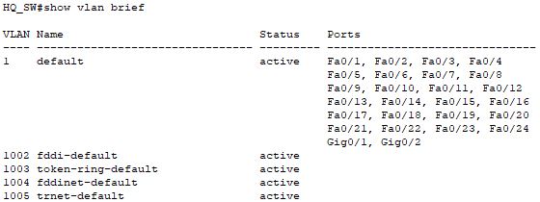
BRANCH_SW Switch Configurations
Assigned the second available IP Address of the BRANCH LAN subnet of 10.38.98.2 with subnet mask 255.255.255.128 to the vlan1 interface.

Verification
show vlan brief
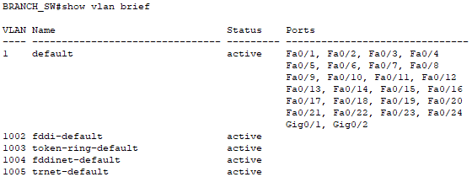
BRANCH Internal Web/Syslog Server Configurations
Assigned the third available IP Address of the BRANCH Internal Web/Syslog Server as 10.38.98.3, subnet mask 255.255.255.128, and the default gateway 10.38.98.1.
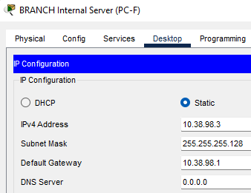

HQ DMZ Web/DNS Server Configurations
Assigned the second available IP Address of the HQ DMZ Web/DNS Server Configurations as 10.38.96.130, subnet mask 255.255.255.224, and the default gateway 10.38.96.129.
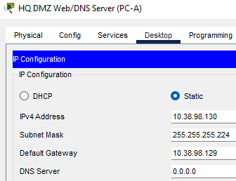

.

- DHCP, NAT/PAT and Wireless LAN Implementation
Task 1
HQ_FW DHCP Configurations
Excluded Address Range: 10.38.96.1 – 10.38.96.10
DHCP Pool Name: INTERNAL
DNS Server IP Address: 10.38.96.130
Domain Name: www.tp.com.sg
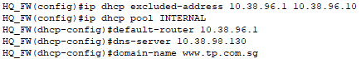Verifications
show run
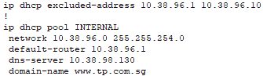
Enabled DHCP on PC-B, automatically assigned the IP Address of 10.38.96.11 to the device.
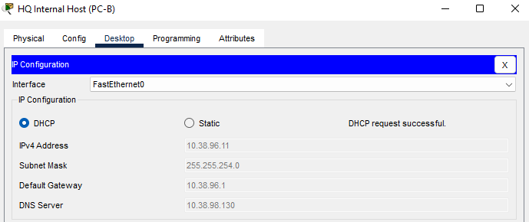

BRANCH DHCP Configurations
Excluded Address Range: 10.38.98.1 – 10.38.98.10
DHCP Pool Name: BRANCH
DNS Server IP Address: 165.16.36.10
Domain Name: www.internet.com
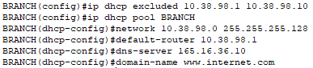Verifications
show run
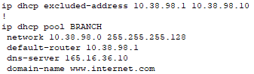
Enabled DHCP on PC-C, automatically assigned the IP Address of 10.38.98.13 to the device.
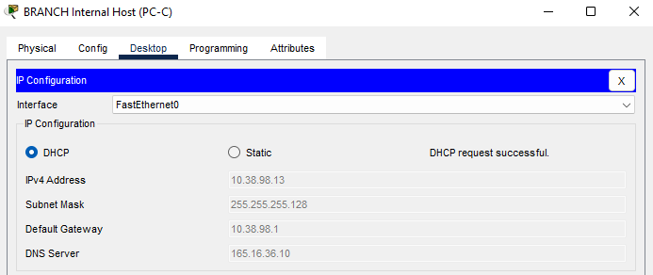
What is purpose to exclude the first 10 IP addresses from both HQ and BRANCH DHCP ranges?
It is to keep the statically assigned assets outside of the DHCP scope and prevent these addresses from being assigned to another random client or host that could lead to IP address conflicts.

HQ_FW Router Static NAT Configuration
Inside Local: 10.38.98.130
Inside Global: 209.165.200.227
Verification
To test if this works, I generated some traffic by pinging from BRANCH LAN’s PC-C to the HQ DMZ Web Server’s public address.
Then, I used the command show ip nat translations to look at the generated traffic from PC-C to the server.
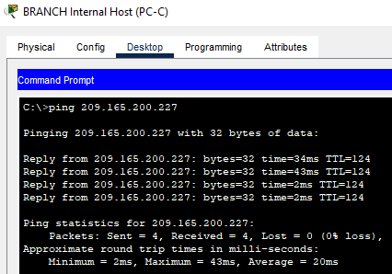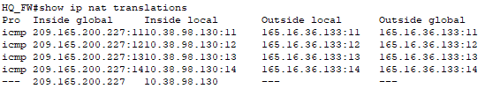

HQ_FW Router Dynamic NAT Configuration
Access List Number: 1
Permitted Network Address: 10.38.98.128
Wildcard: 0.0.0.31
Pool Name: PUBLIC
Dynamic IP Address Range: 209.165.200.228 – 209.165.200.230
Netmask: /29 – 255.255.255.248
BRANCH Router Dynamic PAT Configurations
Access List Number: 1
Permitted Network Address: 10.38.98.0
Wildcard: 0.0.0.127
Interface for IP Translation: S0/0/1

Wireless LAN Router Configurations
Enabling DHCP, it automatically assigned an IP address of 10.38.96.12.
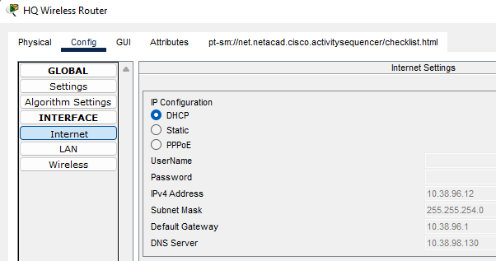
I also assigned the given SSID as TP-WIFI and WPA2-PSK Pass Phrase as TP-Secret.
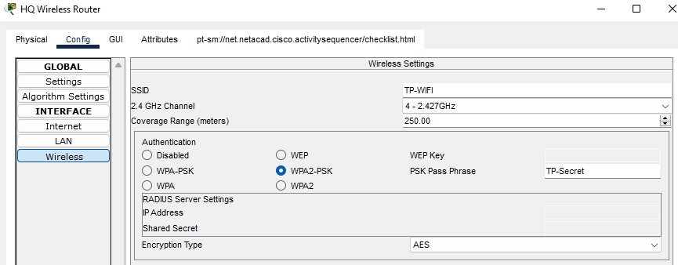

Given the Wireless Router’s Information,
LAN IP Address: 192.168.0.0/24
Router IP Address: 192.168.0.1
Subnet Mask: 255.255.255.0
Maximum Number of Users: 50
IP Address Range: 192.168.0.100 – 192.168.0.149
Static DNS 1: 10.38.98.130
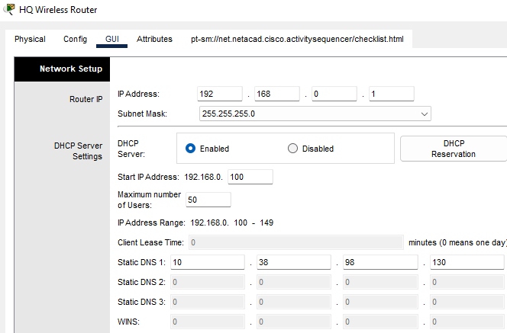
Verifications
After saving the configuration, PC-E’s address was automatically assigned by DHCP of 192.168.0.100 with the assigned DNS Server of 10.38.98.130
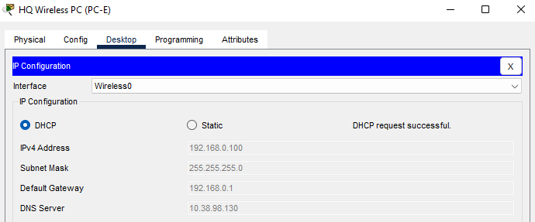
Web Server Access
PC-B
www.tp.com.sg
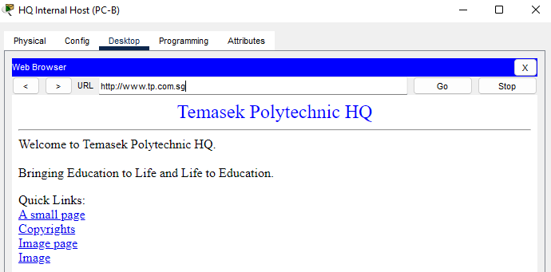
www.internet.com
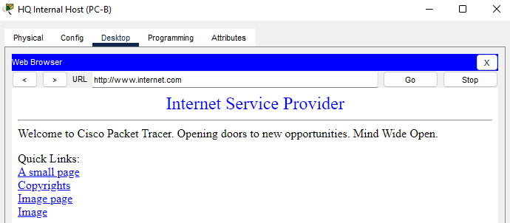

PC-C
www.tp.com.sg (Public Address: 209.165.200.227)
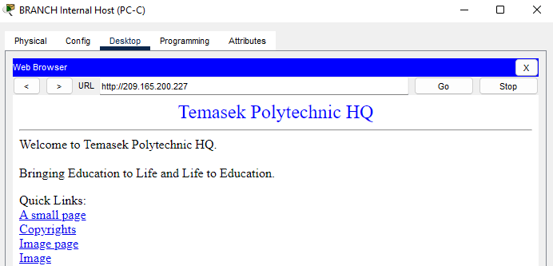
www.internet.com
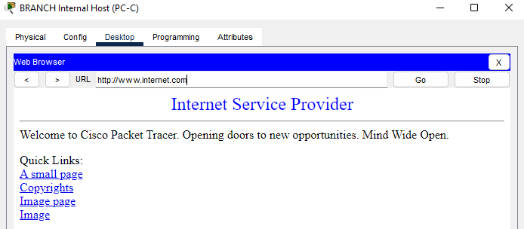

PC-E
www.tp.com.sg
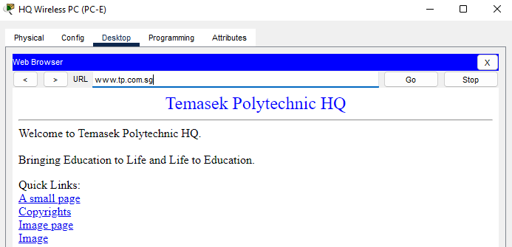
www.internet.com
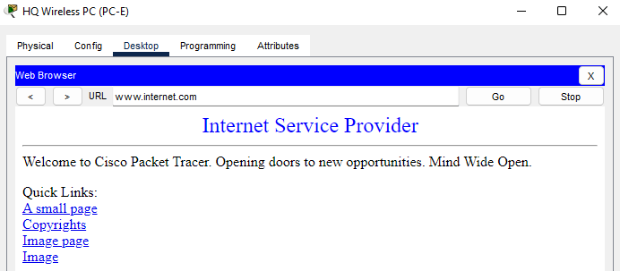

- Security Implementation
4.1 Router Hardening (including Wireless Router Hardening)
4.2 Switch Hardening
4.3 IOS Firewall Implementation
4.3.1 IOS ZPF without DMZ implementation at BRANCH router
4.3.2 IOS ZPF with DMZ implementation at HQ FW router
Part 4.1 Router Hardening (Including Wireless Router Hardening)
Task 1: HQ Perimeter Router Configurations
Configuring Basic Security Features
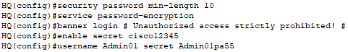
Enabling AAA
aaa authentication enable default enable allows the default login authentication method.
aaa authentication login default local enable includes a backup option if there is an error in the local authentication.
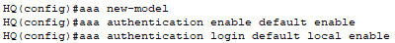Configuring Console Line
The logging synchronous command is to prevent console messages from interrupting the command entry, and the login authentication default command is the aaa authentication default login method.
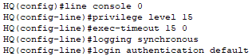

Configuring VTY Line
Using the transport input ssh command for remote access to SSH.
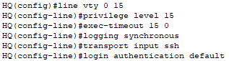
Logging Login Activities
If user encounters 2 failed attempts within a 30-second time span, disables user login for 60 seconds (1 minute).
login on-failure/success log to log login activity on router CLI whether failed or successful.
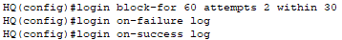

Configuring SSH Server
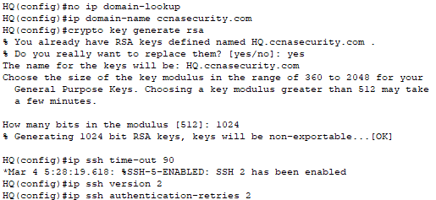
Verification
To test if my SSH configurations work, I can SSH login from PC-D to the HQ perimeter Router, with the username Admin01 and password Admin01pa55.
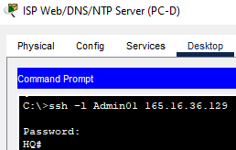

When logging in to the HQ Router, upon successful login, there is a log to show a login success from the logged in user.
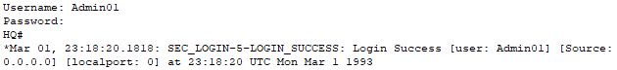
However, for failed login, the log will show a failed login from the user attempting to login.
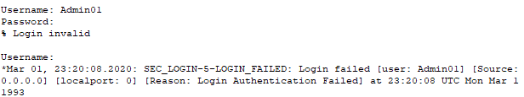

Task 2: HQ_FW and BRANCH Router Configurations
HQ_FW Router
Configuring Basic Security Features
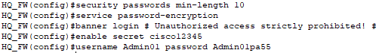
Enabling AAA
Configuring Console Line
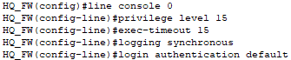
Configuring VTY Line
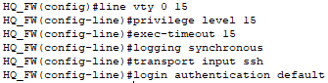
Logging Login Activities
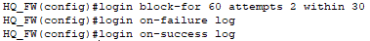

Configuring SSH Server
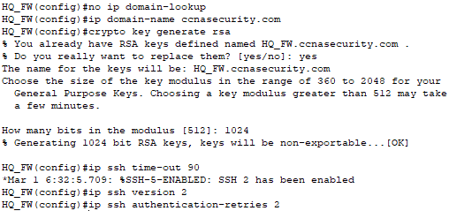

Verification
To test if my SSH configurations work, I can SSH login from PC-B to the HQ_FW Router, with the username Admin01 and password Admin01pa55.
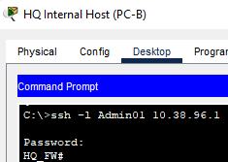

When logging in to the HQ_FW Router, upon successful login, there is a log to show a login success from the logged in user.
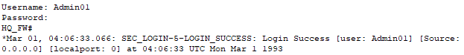
However, for failed login, the log will show a failed login from the user attempting to login.
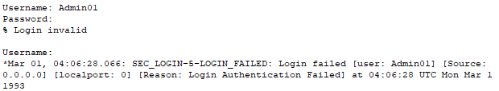

BRANCH Router
Configuring Basic Security Features
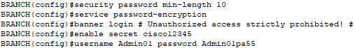
Enabling AAA
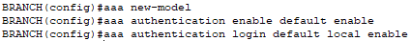
Configuring Console Line
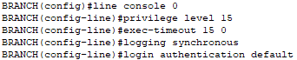
Configuring VTY Line
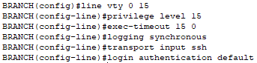
Logging Login Activities
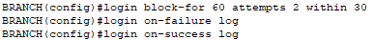

Configuring SSH Server
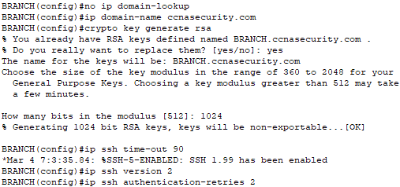
Verification
To test if my SSH configurations work, I can SSH login from PC-C to the BRANCH Router, with the username Admin01 and password Admin01pa55.
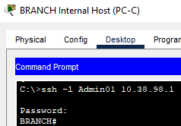

When logging in to the BRANCH Router, upon successful login, there is a log to show a login success from the logged in user.
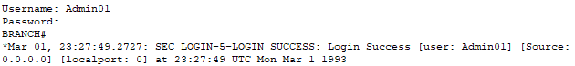
However, for failed login, the log will show a failed login from the user attempting to login.
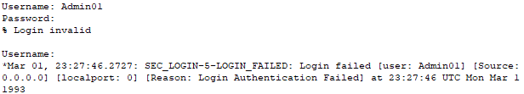

Task 3: Configuring NTP
Turned on and enabled NTP at master NTP clock source (ISP Web Server), default date set to 1 March 1993, assigned key to be 1, and assigned password as NTPpassword.
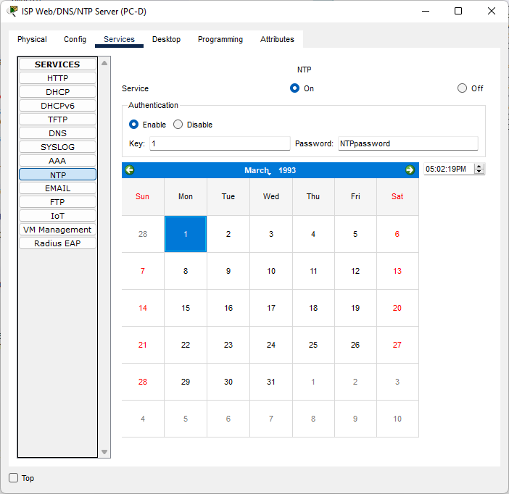

HQ Router NTP Configuration
ntp server 165.16.36.10 key 1 to specify the NTP clock source server and the authentication key.
ntp authenticate to authenticate the time sources
ntp trusted-key 1 to use the key number for the trusted time source
ntp authentication-key 1 md5 NTPpassword to use the authentication key for the trusted time source
ntp update-calendar to configure NTP to constantly update the calendar
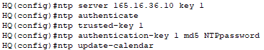

BRANCH Router NTP Configuration
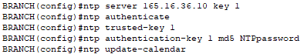

Verification
After configuring, both routers displayed the same time when used the show clock command to check the time and date and are also synchronized with each other when used the show ntp status command. The date and time are also synchronized with the NTP server.
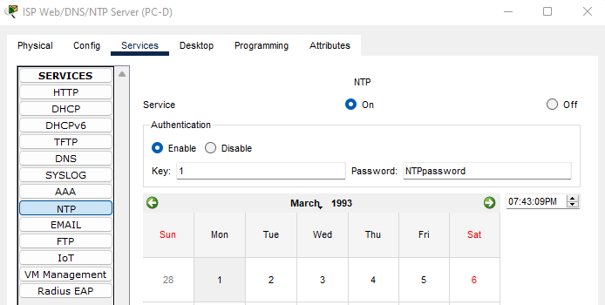
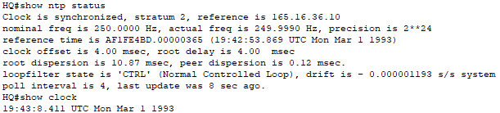
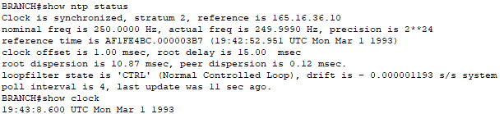

Task 4: Configuring Syslog Support at BRANCH Router
Turning on the Syslog Service at the BRANCH internal server.
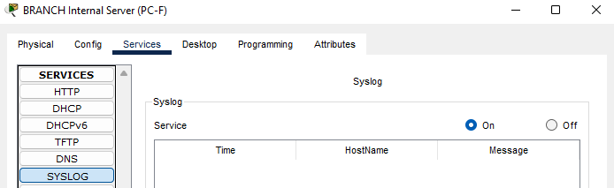
Verifying ping from BRANCH Router to Syslog Server.
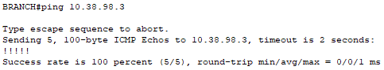
Used the command service timestamps log datetime msec to enable the timestamp service.
logging host 10.38.98.3 for the BRANCH Router to send syslog messages to the Syslog Server.
Since Packet Tracer does not have logging severity to level 4, it only accepts level 7, or debugging severity, since it is its default setting, and nothing can be done to configure it to another severity level.
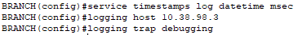

Task 5: Wireless Router Hardening
SSID and WPA2-PSK assigned to TP-WIFI and TP-Secret respectively.
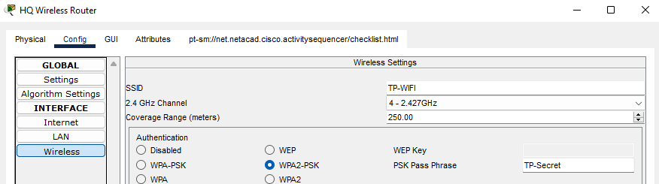
Assigned the DNS Server as 10.38.98.130, according to my DMZ LAN Address.
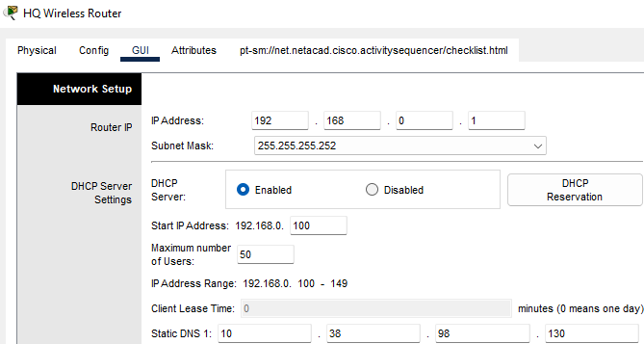

Part 4.2: Switch Hardening
Task 1: HQ_SW and BRANCH_SW Security Configurations
In this Packet Tracer, there is no option for disabling any HTTP Servers on the switch, hence there is also nothing that can be done to disable or configure the HTTP Servers on the switch.

HQ_SW Switch
Configuring Basic Security Features
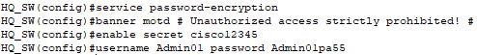
Configuring Console Line
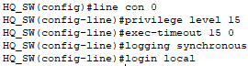
Configuring VTY Line
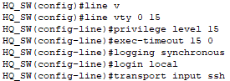

Configuring SSH Server
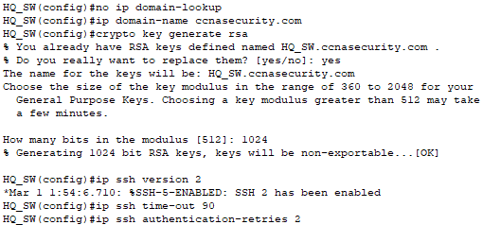
Verification
To test if my SSH configurations work, I can SSH login from PC-B to the HQ_SW Switch, with the username Admin01 and password Admin01pa55.
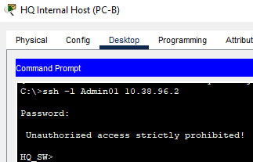

BRANCH_SW Switch
Configuring Basic Security Features
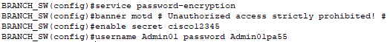
Configuring Console Line
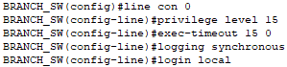
Configuring VTY Line
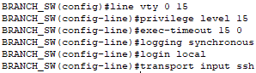

Configuring SSH Server
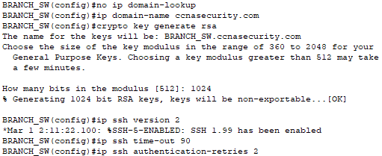Verification
To test if my SSH configurations work, I can SSH login from PC-C to the BRANCH_SW Switch, with the username Admin01 and password Admin01pa55.
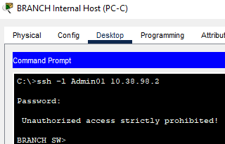

Task 2: Configuring Port Security and Disable Unused Ports
HQ_SW Switch
Setting Access Ports and Disabling Trunk Ports
Commands:
int range f0/1-24
switchport mode access
spanning-tree portfast
spanning-tree bpduguard enable

switchport port-security
switchport port-security maximum 2
switchport port-security mac-address sticky
switchport port-security violation shutdown

int range f0/1-17, f0/20-23
shutdown

Verification
show run
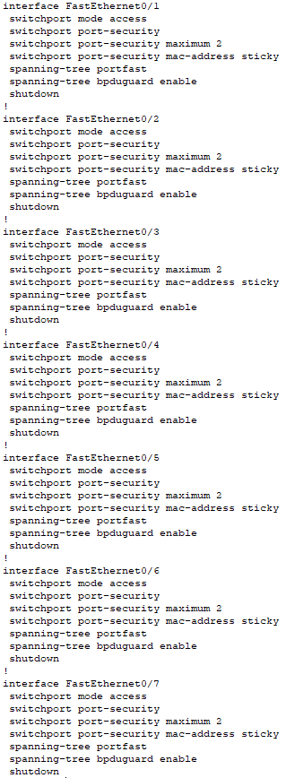

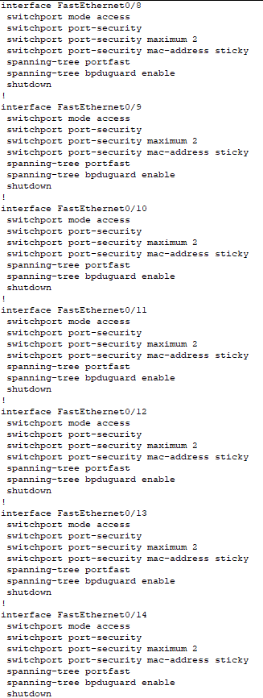
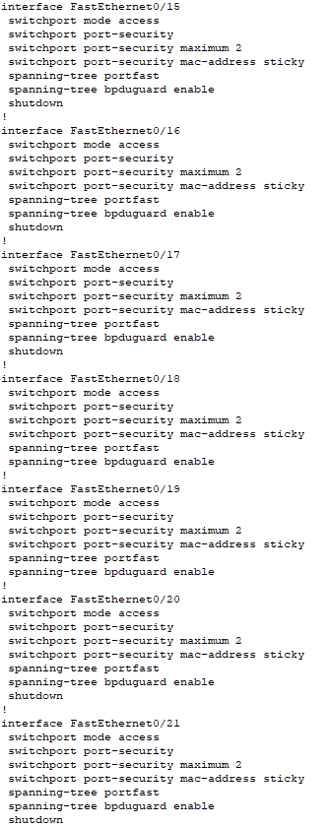

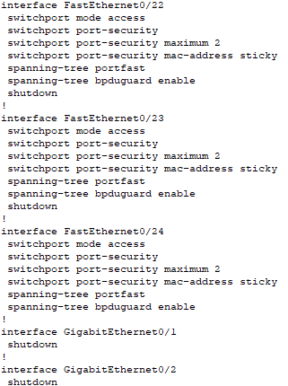

All ports except G0/1-2 have:
Switchport access mode
STP PortFast mode enabled
BPDU guard enabled
Port security enabled
Maximum MAX addresses set to 2
Violation action set to shutdown
Sticky option enabled

Only ports F0/18, F0/19, and F0/24 are in use, whereas the rest are all shutdown.

BRANCH_SW Switch
int range f0/1-24
switchport mode access
spanning-tree portfast
spanning-tree bpduguard enable

switchport port-security
switchport port-security maximum 2
switchport port-security mac-address sticky
switchport port-security violation shutdown

int range f0/1-4, f0/6-17, f0/20-24
shutdown

Verification
show run
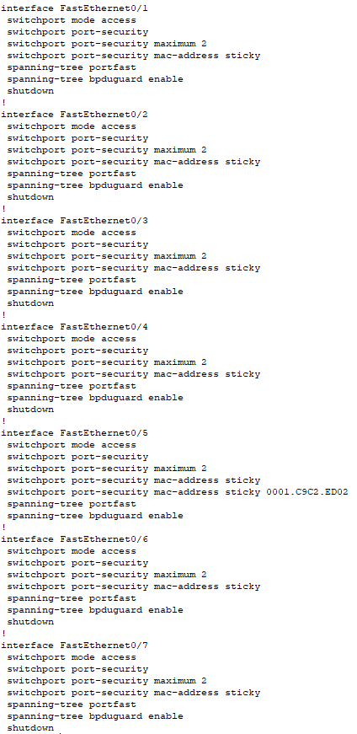
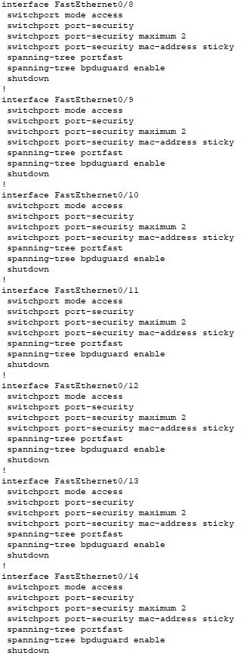
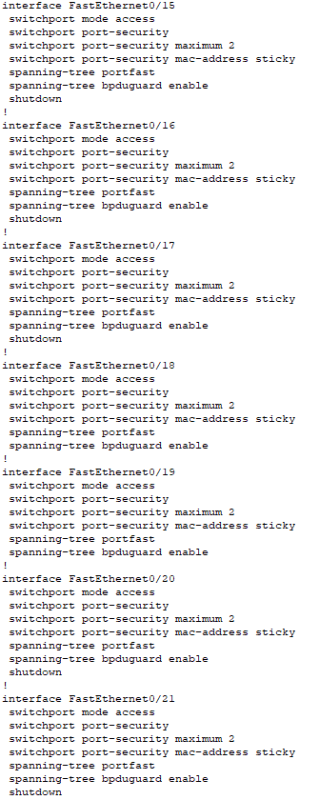

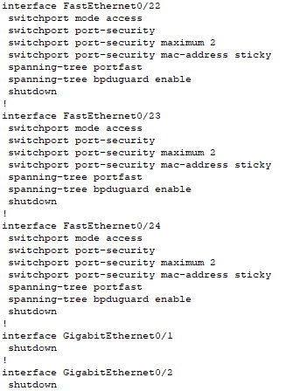

All ports except G0/1-2 have:
Switchport access mode
STP PortFast mode enabled
BPDU guard enabled
Port security enabled
Maximum addresses set to 2
Violation action set to shutdown
Sticky option enabled

Only ports F0/5, F0/18, and F0/19 are in use, whereas the rest are all shutdown.

What happen when a host PC is connected to a switch access port that is set to portfast mode, and why is it safe to configure portfast mode on all switch access ports?

When a host PC is connected to a switch access port with portfast mode, the user will be able to connect to the network and bypass the STP listening and learning states to minimize the time that access ports must wait for STP to converge.

Portfast is safe to configure on all switch access ports because portfast helps mitigate STP manipulation attacks.

What is the purpose of setting BPDU guard on switch access ports?

The BPDU guard feature provides a secure response to invalid configurations because one must manually put the interface back in service. Using the BPDU guard feature in a service-provider network prevents an access port from participating in the spanning tree.

Part 4.3.1: IOS ZPF Without DMZ Implementation (BRANCH Router)
Task 1: Creating ZPF for BRANCH Internal LAN to pass through ZPD to access public networks
Commands
zone security INSIDE
exit
zone security OUTSIDE
exit

class-map type inspect match-any ALLOWED-PROTOCOLS
match protocol icmp
match protocol udp
match protocol tcp
exit

policy-map type inspect INSIDE-TO-OUTSIDE
class type inspect ALLOWED-PROTOCOLS
inspect
exit
exit

zone-pair security INSIDE-TO-OUTSIDE source INSIDE destination OUTSIDE
service-policy type inspect INSIDE-TO-OUTSIDE
exit

Task 2: Configuring ZPF policy to allow traffic return from public network to internal LAN
Commands:
access-list 101 permit ip any 10.38.98.0 0.0.0.127
class-map type inspect match-all ALLOWED-TRAFFIC
match access-group 101
match class-map ALLOWED-PROTOCOLS
exit

policy-map type inspect OUTSIDE-TO-INSIDE
class type inspect ALLOWED-TRAFFIC
inspect
exit
exit

zone-pair security INSIDE-TO-OUTSIDE source INSIDE destination OUTSIDE
service-policy type inspect INSIDE-TO-OUTSIDE
exit

zone-pair security OUTSIDE-TO-INSIDE source OUTSIDE destination INSIDE
service-policy type inspect OUTSIDE-TO-INSIDE
exit

Task 3: Assign BRANCH Router interfaces
Commands:
int g0/1
zone-member security INSIDE
exit

int s0/0/1
zone-member security OUTSIDE
exit

Verification
class-map ALLOWED-PROTOCOLS to match all 3 protocols: tcp, udp, and icmp.
class-map ALLOWED-TRAFFIC to match ACL 101 and match ALLOWED-PROTOCOLS with the other inspected protocols.
Created INSIDE and OUTSIDE zones, and identifying zone-pair and assigning a created policy to it.
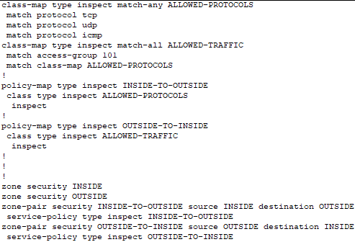

Assigned the INSIDE zone to interface G0/1, and OUTSIDE to S0/0/1
Since BRANCH g0/1 is connected to private LAN, zone is INSIDE
Since BRANCH s0/0/1 is connected to public LAN, zone is OUTSIDE
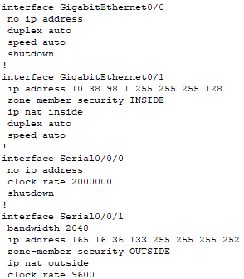

Created ACL 101 for ALLOWED-TRAFFIC class-map

Q: Why destination is BRNACH private LAN addresses and NOT its equivalent public PAT address or 165.16.36.133?

BRANCH private LAN is a static address and can accurately determine the return destination IP address, as PAT of the private IP addresses is dynamic.
Although private IP addresses are translated to public through PAT, the private addresses are still dynamically assigned to an unused port with the public IP address after translation.

Q: What is the purpose of this policy-map?

It is to ensure all packets matching both the ACL 101 and ALLOWED-PROTOCOLS class policy will be allowed to pass through the firewall and into the BRANCH private LAN.
The created ACL 101 permits any packet from an external network with a destination of the BRANCH private IP address, and the ALLOWED-PROTOCOLS class policy will inspect packets that matches one of the included protocols (tcp, udp, or icmp).

- Conclusions
Throughout this assignment, I learnt how to configure Static and Dynamic NAT and PAT, learning how to configure switch and router hardening, and learning how to implement ZPF on routers to ensure security when sending out and receiving packets throughout the network.
I also learnt about the different network attacks and how to mitigate these attacks, such as VLAN Hopping Attack, or the STP manipulation attacks.

Appendices
HQ ROUTER CONFIGURATIONS
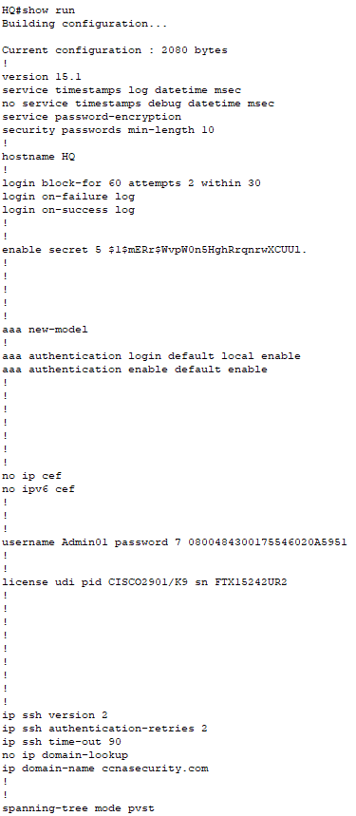

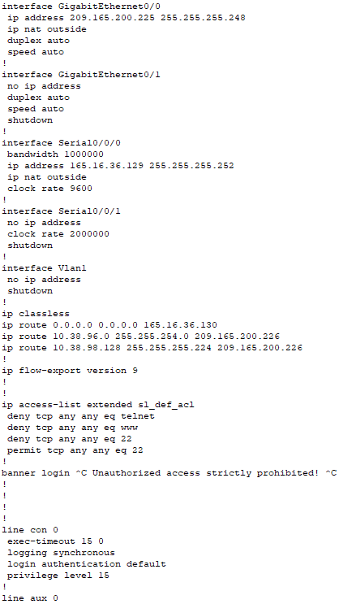

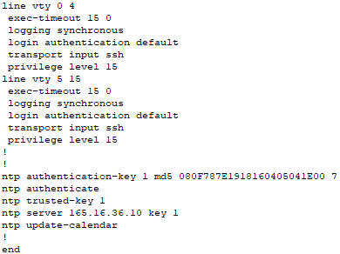

HQ_FW ROUTER CONFIGURATIONS
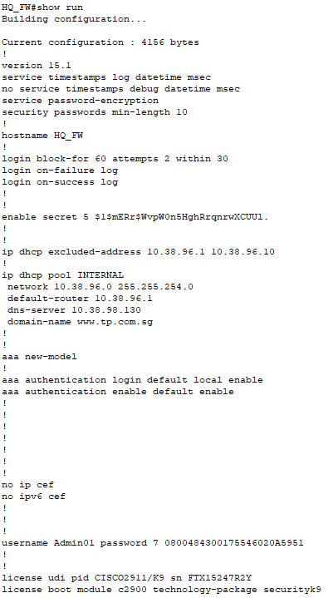

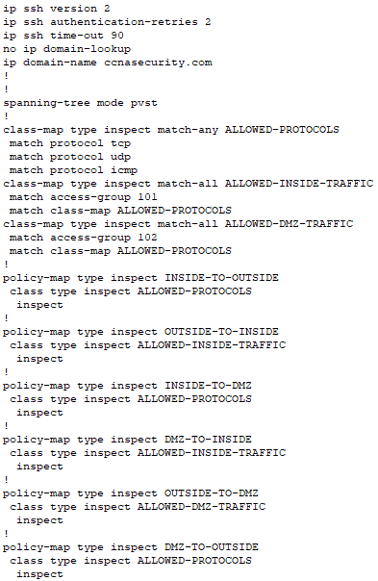

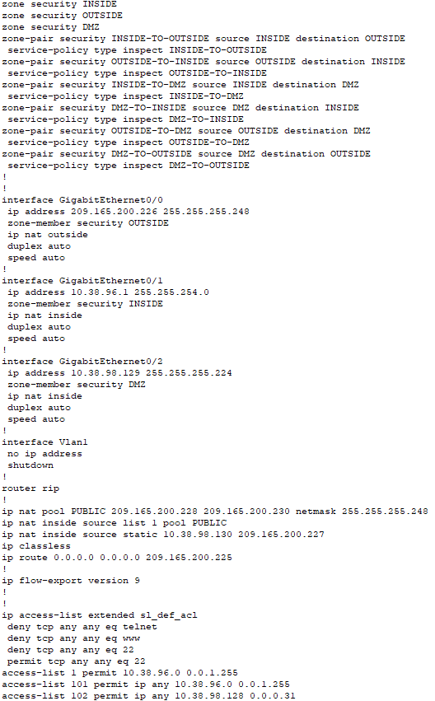
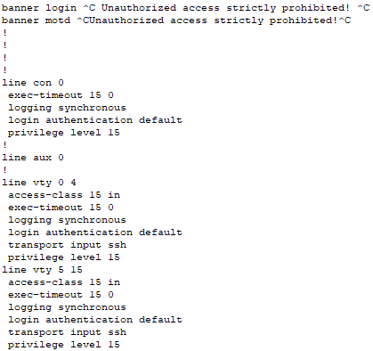

BRANCH ROUTER CONFIGURATIONS
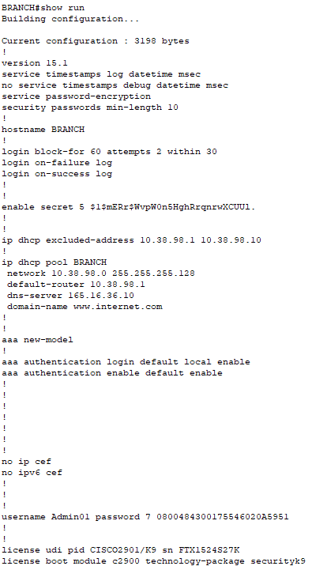

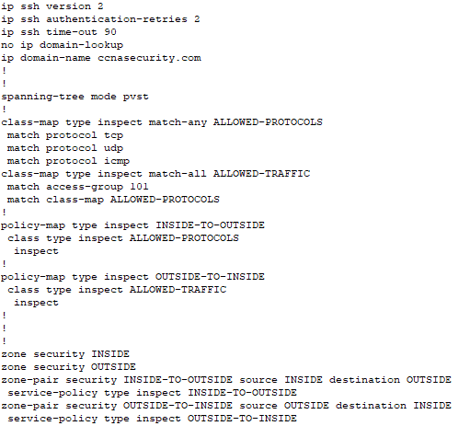

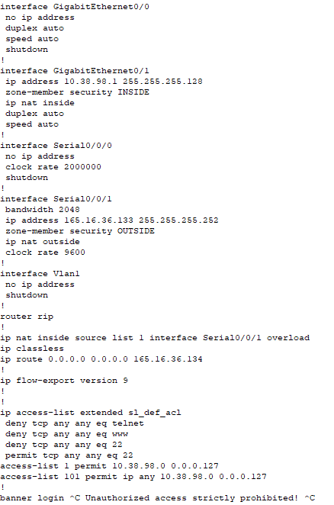

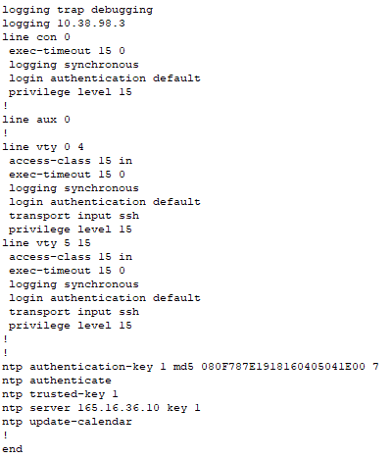

ISP ROUTER CONFIGURATIONS

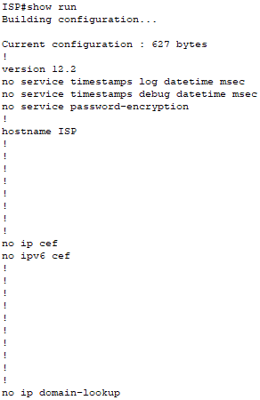

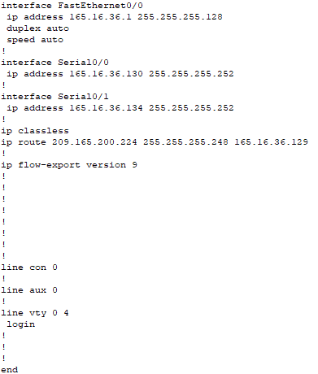

HQ SWITCH CONFIGURATIONS
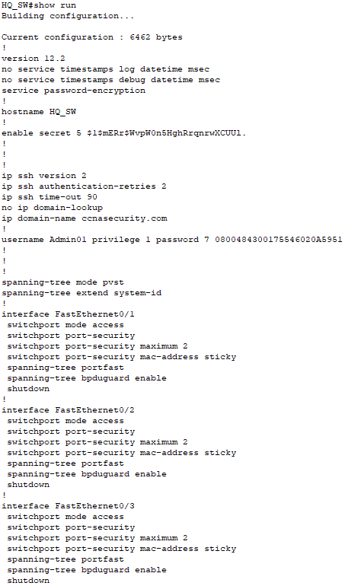

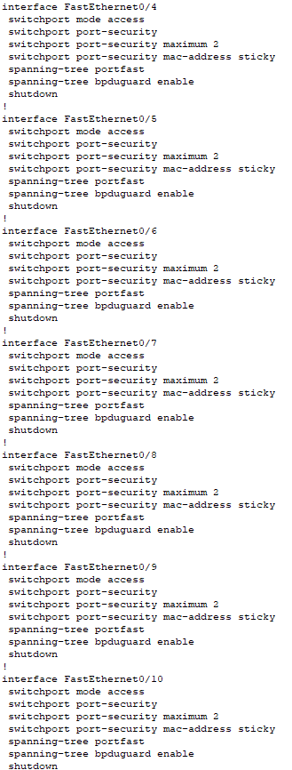
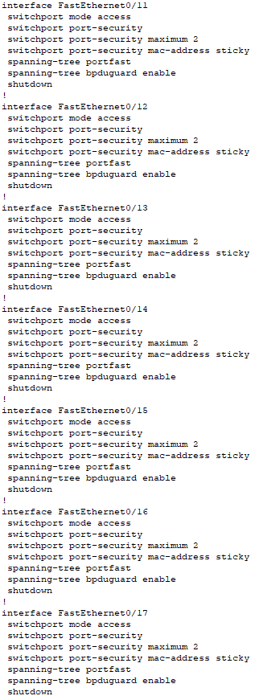
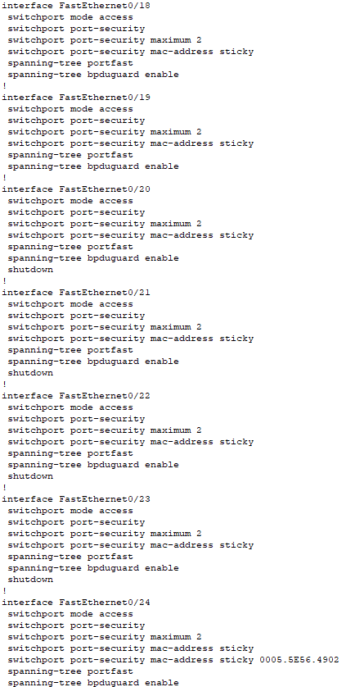

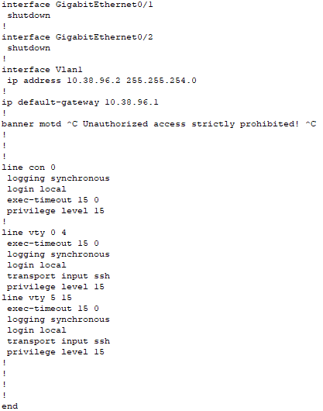

BRANCH SWITCH CONFIGURATIONS
